# Share Your Thoughts

## Architecture Diagram

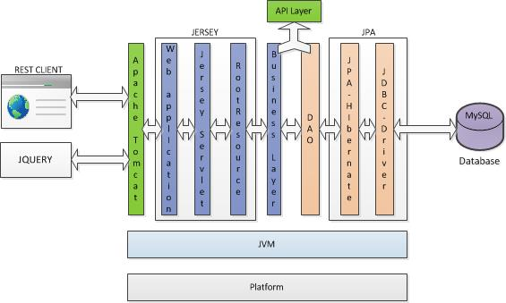

## Use case diagram

As per requirements, identified resources.

### Resources :

Authors/Users – will be blog User as per requirement.

Posts

Comments

Ratings

Operation are identified and mentioned as interface.

## Model Diagram

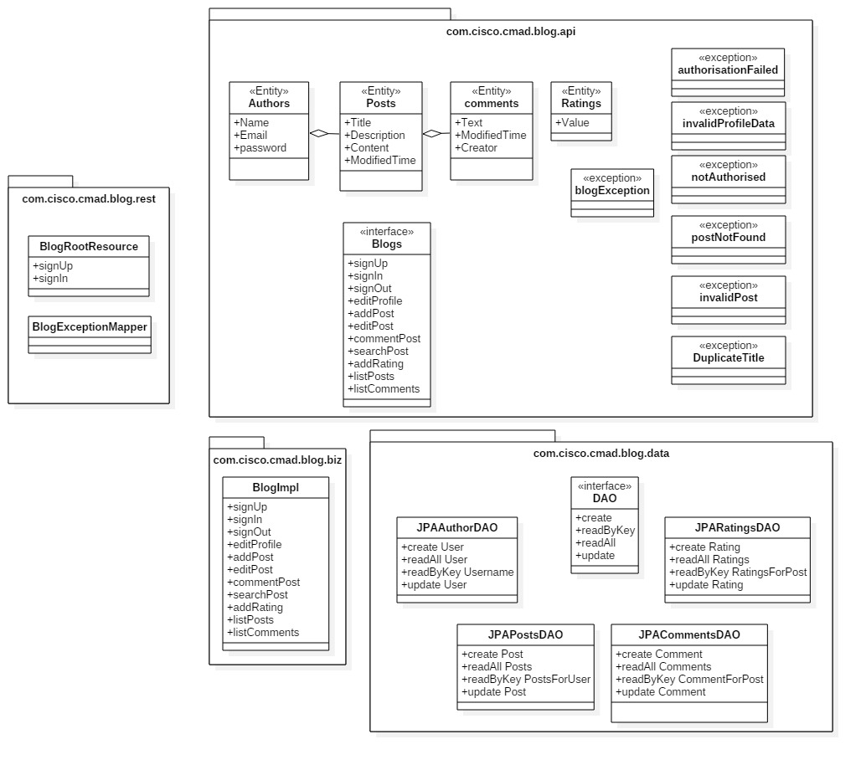

## Guidelines used for designing REST APIs

* + - * 1. Use Noun

Use Plural resources

Use versioning for API

Return location for POST and PUT operations

Use filter, sort and pagination.

Use alias for queries

|  |  |  |  |  |
| --- | --- | --- | --- | --- |
| Title | URL | Method | Response Code | Params / Data |
| List all posts for visitor | /rest/syt/v1/posts/recent alias  /rest/syt/v1/posts?sort=-ModifiedTime | GET | 200 OK |  |
| 404 Not found |
| Search post | /rest/syt/v1/posts?Title={text} | GET | 200 OK | all the available blog title would be matched against the provided text |
| 404 Not found |
| Register new user | /rest/syt/v1/users | POST | 201 Created | {email, Name,password} |
| 403 Forbidden |
| 400 Bad request |
| Sign In | /rest/syt/v1/users | POST | 200 OK | {email,password} |
| 401 Unauthorized |
| 400 Bad request |
| 404 Not found |
| List all blogs by given user | /rest/syt/v1/users/{userid}/posts/ | GET | 200 OK |  |
| 404 Not found |
| Sign Out | /rest/syt/v1/users/{userid} | POST | 200 OK | {action: logout} |
| 404 Unauthorized |
| 404 Not found |
| Post new post | /rest/syt/v1/users/{userid}/posts | POST | 201 Created | {Title,content} |
| 400 Bad request |
| 401 Unauthorized |
| View post | /rest/syt/v1/users/{userid}/posts/{postid} | GET | 200 O |  |
| K404 Not found |
| Edit post | /rest/syt/v1/users/{userid}/posts/{postid} | PUT | 200 OK | {new content} |
| 400 Bad Request |
| 401 Unauthorized |
| 404 Not found |
| All comments for post | /rest/syt/v1/users/{userid}/posts/{postid}/comments | GET | 200 OK |  |
| 404 Not found |
| Post new comment | /rest/syt/v1/users/{userid}/posts/{postid}/comments | POST | 201 Created | {commenting_user,comment_text} |
| 401 Unauthorized |
| 400 Bad request |
| 404 Not found |
| Get rating for post | /rest/syt/v1/users/{userid}/posts/{postid}/ratings | GET | 200 OK |  |
| 404 Not found |
| Post / Update rating for a post | /rest/syt/v1/users/{userid}/posts/{postid}/ratings | POST | 201 Created | {rating: <1 .. 5>} |
| 401 Unauthorized |
| 400 Bad request |
| 404 Not found |
| Note: All the 201 Created response are accompanied by new created resource location. | | | | |

## Mock up Screens

### Home Screen

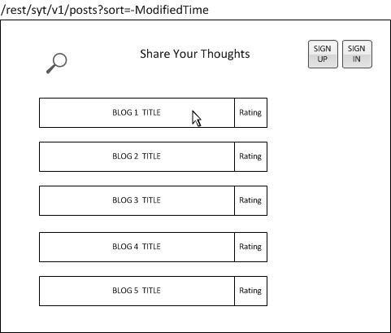

### Visitor viewing blog

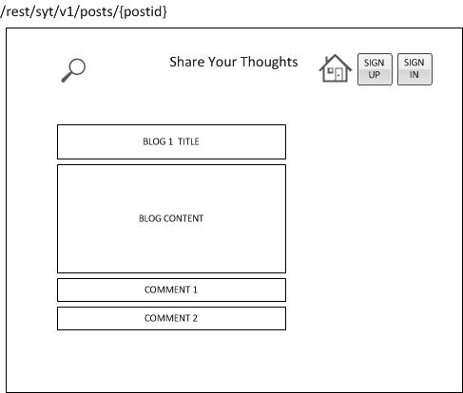

### Visitor Searching blog

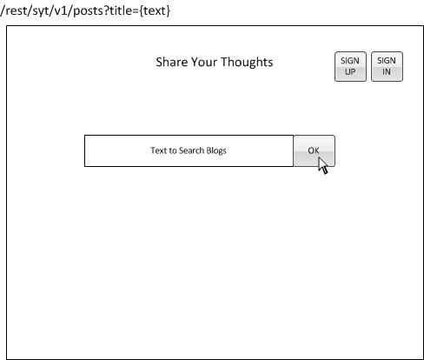

### Sign up

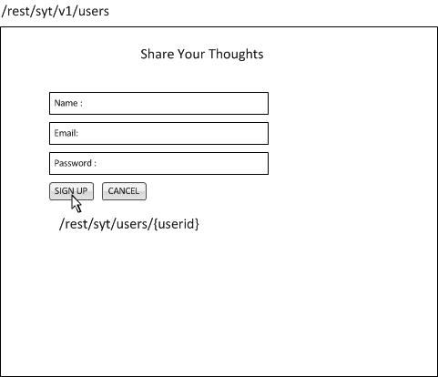

### Sign In

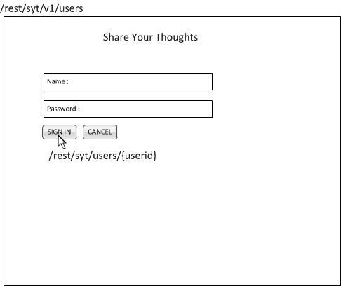

### User Home Page

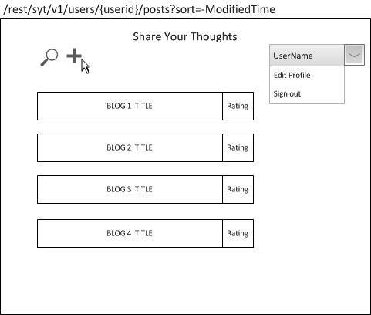

### User adding Post

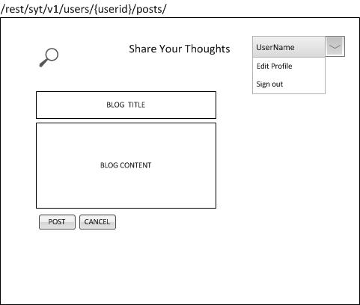

### User editing blog

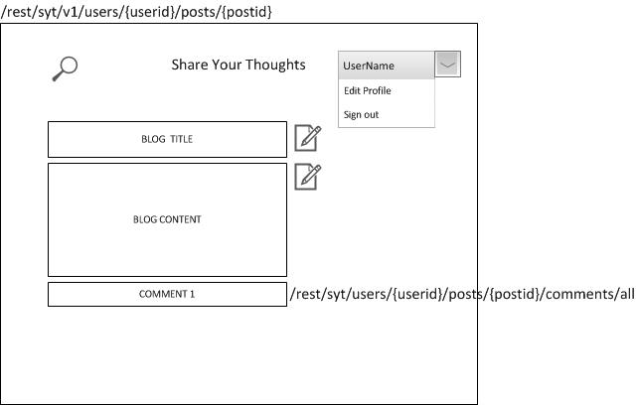

### User searching blog

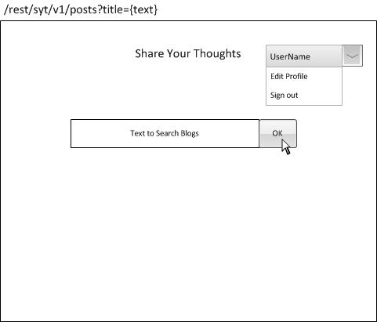

### User adding comment

